Technical Description
Rail Vehicle Technology
Transportation and Logistics
© WorldSkills International

TDXX v0.0 WSC2021
The Technical Description is the draft and the reference for the proposal inspection, it will be completed in future.
WorldSkills International, by a resolution of the Competitions Committee and in accordance with the Constitution, the Standing Orders and the Competition Rules, has adopted the following minimum requirements for this skill for the WorldSkills Competition.
The Technical Description consists of the following:
1 Introduction 2
2 The WorldSkills Standards Specification (WSSS) 4
3 The Assessment Strategy and Specification 11
4 The Marking Scheme 12
5 The Test Project 15
6 Skill management and communication 22
7 Skill-specific safety requirements 23
8 Materials and equipment 24
9 Skill-specific Rules 26
10 visitor and media engagemenT 27
11 Sustainability 28
12 References for industry consultation 29

Effective
Stefan Praschl  Chair of the Competitions Committee | Michael Fung  Vice Chair of the Competitions Committee
© WorldSkills International (WSI) reserves all rights in documents developed for or on behalf of WSI, including translation and electronic distribution. This material may be reproduced for non-commercial vocational and educational purposes provided that the WorldSkills logo and copyright notice are left in place.

Introduction

Name and description of the skill competition

The name of the skill competition is
Rail Vehicle Technology

Description of the associated work role(s) or occupation(s).
The carriage capacity of rail transit ranks the top of the world, and it is important and irreplaceable. It significantly improves the travel efficiency and the living quality. The rail transit is the first green transportation system around the world due to its safety, convenience, punctuality and speed. Currently, the global rail transit operation mileage is over 1 million kilometers. Rail transit has great potentials for rapid and sustainable development.
Regarding rail transit operation maintenance, the Rail Vehicle Technology consisted of diverse skills and procedures. The modern rail vehicle is a transportation means with integrated technologies. Thus, the rail vehicle technician should have various skills, generally, individual rail vehicle technician could not be excellent in every aspect. In this regards, the rail vehicle operation maintain adopts a team work approach, and members have their own specialty and play different technical roles.
Rail Vehicle Technology has great employment opportunity, the rail transit technician may undertake a series of working procedures, including vehicle inspection, maintenance, disassembly, assembly, repairing, commissioning, troubleshooting, etc. For maintaining the safe operation of the whole line’s vehicles, the rail vehicle technician should work efficiently in given time by proposing general solutions and preventive measures for various operation faults in order to maintain the continuous running. When the vehicle operation mileage or operation time reaches defined values as standard, they should carry out the work according to the vehicle repair specifications and process standards. A working team is generally composed of two or more professional technicians who carry out mechanical and electrical maintenance. When repairing the vehicle, they collaborate to accomplish the repair work and vehicle commissioning work for vehicle high voltage current collection and traction system, air supply and brake system, door system, vehicle bogie system, air-conditioning system, and so on, by assuring the safety, efficiency and economy of the process.
High performing rail vehicle technician has comprehensive or professional rail vehicle related skills. They should understand the vehicle structure and device working principle, vehicle control principle, vehicle maintenance and repair standards and processes; they have to keep abreast of the current Rail Vehicle Technology development and apply the new technologies and methods in their working process. They should be able to play their key technical roles in a team. These require the rail vehicle technicians to keep improving their skills for solving more complicated diagnostic tasks, repair vehicles that adopt the most advanced and new technology. Further skill development of the rail vehicle technicians would enable them in employment challenges and advancement, including promoting to leading or management positions.

Number of Competitors per team
Rail Vehicle Technology is a team skill competition with two Competitors per team.

Age limit of Competitors
The Competitors must not be older than 22 years in the year of the Competition.

The relevAnce and significance of this document
This document contains information about the standards required to compete in this skill competition, and the assessment principles, methods and procedures that govern the competition.
Every Expert and Competitor must know and understand this Technical Description.
In the event of any conflict within the different languages of the Technical Descriptions, the English version takes precedence.

Associated documents
Since this Technical Description contains only skill-specific information it must be used in association with the following:
- WSI – Competition Rules
- WSI – WorldSkills Standards Specification framework
- WSI – WorldSkills Assessment Strategy
- WSI Online resources as indicated in this document
- WorldSkills Health, Safety, and Environment Policy and Regulations.

The WorldSkills Standards Specification (WSSS)

General notes on the WSSS
The WSSS specifies the knowledge, understanding and specific skills that underpin international best practice in technical and vocational performance. It should reflect a shared global understanding of what the associated work role(s) or occupation(s) represent for industry and business (www.worldskills.org/WSSS).
The skill competition is intended to reflect international best practice as described by the WSSS, and to the extent that it is able to. The Standards Specification is therefore a guide to the required training and preparation for the skill competition.
In the skill competition the assessment of knowledge and understanding will take place through the assessment of performance. There will only be separate tests of knowledge and understanding where there is an overwhelming reason for these.
The Standards Specification is divided into distinct sections with headings and reference numbers added.
Each section is assigned a percentage of the total marks to indicate its relative importance within the Standards Specification. This is often referred to as the “weighting”. The sum of all the percentage marks is 100.
The Marking Scheme and Test Project will assess only those skills that are set out in the Standards Specification. They will reflect the Standards Specification as comprehensively as possible within the constraints of the skill competition.
The Marking Scheme and Test Project will follow the allocation of marks within the Standards Specification to the extent practically possible. A variation of five percent is allowed, provided that this does not distort the weightings assigned by the Standards Specification.

WorldSkills Standards Specification
SECTION |  | RELATIVE IMPORTANT  (%)
1 | Work organization and management | 5
The individual needs to know and understand:
- Rail vehicle maintenance manual
- Health and safety legislation, obligations and documentation
- Approved manuals, data from manufacturers and government
- Situations when personal protective equipment (PPE) must be used, to include: safety helmet, safety footwear, labour suit, eye and hearing protection, gloves, and respirators
- Safety protection measures for working environment (site)
- The purposes, uses, care and safe storage of materials
- Sustainability measures with respect to the use of environmentally friendly materials, minimization of waste, and recycling materials
- Principles of work flow, time management, measurement, and cost analysis
- The importance of researching, planning, accuracy, checking, and attention to detail in all working practices
- The importance of working within a team to accomplish a task within a timely and economical manner
- The importance of team work
- Individual roles and responsibilities within a team setting
- Strength and weaknesses of team members and how to best organize the team to optimise resources that are available
The individual shall be able to:
- Consistently and diligently follow health and safety standards, rules and regulations
- Identify and use the appropriate personal protective equipment including: safety helmet, safety footwear, labor suit, ear and eye protection, protection gloves
- Organise site protection measures and ensuring the working environment safety
- Apply professional skills in current job
- Select, use, clean, maintain and store all tools and equipment safely
- Select, use and store all materials safely
- Plan the work area to maximize efficiency
- Maintain the discipline of keeping the work area clean and tidy
- Use the latest version of the approved manual and data, follow the vehicle repair defined processes and procedures
- Establish and consistently maintain high quality standards and working processes under pressure
- Plan the workflow within a team environment to give the best chance for a safe, successful competition of the task within a given time period
- Organize and carry out a set of tasks within a team environment
2 | Communication and interpersonal skills | 5
The individual needs to know and understand:
- The significance of establishing and maintaining customer confidence
- The roles and responsibilities of related colleagues
- The value of building and maintaining productive working relationships
- The importance of having/developing an Industry accepted attitude
- interpersonal techniques of effective team work
- The importance of swiftly resolving misunderstandings and conflicting demands
- Human factors
The individual shall be able to:
- Interpret customer requirements and manage customer expectations positively
- Make recommendations which meet/exceed the customers’ requirements and budget
- Produce a cost and time estimate for customers
- Contribute positively to a team, e.g., in order to maintain safety
- Undertake investigative discussions e.g., to resolve technical problems
- Keep colleagues regularly informed/up-dated on planned maintenance procedures and negotiate timings to minimize negative impact on work/productivity levels
- Reflect positively and constructively to feedback on own performance
- Recognize the needs of support organizations, e.g., logistical supplier, engineering authority
3 | Problem solving, innovation, and planning | 10
The individual needs to know and understand:
- The common types of problem which can occur within the work process
- Make sure to carry out all the activities by following the international standard
- Diagnostic approaches to problem solving
- The importance of following the manufacturer’s latest “Amended Issue” manual and document, in the problem solving processes
- Trends and developments in the industry including new materials, methods and technology
- The importance of making safe, timely and economical work plan while collaborating in team ambience
The individual shall be able to:
- Check work regularly to minimize problems at a later stage
- Challenge incorrect command and regulations to prevent problems
- Recognize and understand problems swiftly and follow a self-managed process for solving them using manufacturer’s latest maintenance manual and document
- Undertake fault diagnosis discussions with drivers to determine the underlying causes of technical problems
- Persist in solving complex problems
- Recognize opportunities to contribute ideas to improve the product and overall level of customer satisfaction
- Demonstrate a willingness to try new methods and embrace change
- Interpret and apply vehicle maintenance procedures
- Encourage check self and team member’s work to make sure it follows the international railway standard
4 | Vehicle mechanical part repairing, maintenance and commissioning | 35
The individual needs to know and understand:
- International Union of Railways (UIC), The International Electrotechnical Commission (IEC) standards
- The manufacture’s vehicle maintenance manual
- The vehicle overall or parts repair standard rules, procedures, methods and so on
- Vehicle’s composition structure, mainly including: vehicle roof, vehicle body, driver's cab, passenger compartment, underframe, gangway, etc.
- The main component structure and motion principle, especially the core parts as pantograph, vehicle door, vehicle bogie, and etc.
- The correct procedure for the main component check, disassembly, assembly, commissioning, maintenance and test
- Inspect and repair tools
- Inspect and repair the relate material inventory
- The hazard elements during work and corresponding safety protection measures
The individual shall be able to:
- Make personal and site safety protection based on working condition
- Read and understand the vehicle and parts structure diagram, operation manual, repair maintenance manual which are supplied by manufacture
- Identify various exclusive material for vehicle repair
- Identify various vehicle repair tools and master their usage
- Master the inspection measures，such as visual detection, tactile detection, measuring, testing, etc.
- Master parts maintenance measures, such as dedusting, cleaning, lubricating, adjusting, fastening, change, and etc.
- Follow repair procedures to check vehicle and its parts
- Identify vehicle parts defects and faults
- Use the correct tool and method to disassembly and assembly vehicle parts
- Test the main vehicle parts’ mechanical motion and identify abnormal status
- Adjust the motion and status parameters for the main vehicle parts to ensure that they meet the technical requirements
- Record the working reports correctly
5 | Vehicle electrical system care, maintenance and testing | 35
The individual should know and understand:
- International Union of Railways (UIC), The International Electrotechnical Commission (IEC) standards
- Manufacture’s vehicle maintenance manual
- The standard rules, procedures, methods and so on for vehicle’s each electrical system maintenance, care and test
- The electrical structure of vehicle
- The vehicle electrical subsystem’s composition, working principle, control principle, it mainly contains: high voltage traction system, brake system, electrical assistant system, vehicle door control system, air conditioning system, network and monitoring system, fire alarm system, passenger information system, lighting system, etc.
- The vehicle electrical installation wiring process standard
- The vehicle standard electrical legends, icons, symbols
- The usage for electrical equipment, tools and gauges
- The electrical material knowledge
- The hazard elements during electrical work and corresponding safety protection measures
The individual should be able to:
- Making personal and site safety protection based on working condition
- Read and understand each electrical subsystem’s principle diagram, assembly diagram, wiring diagram, electrical layout diagram, maintenance manual and so on which are supplied by manufacture
- Identify various vehicle electrical components
- Identify various vehicle electrical instruments (including Ground Test Bench, commissioning software, etc.), tools and gauges and master their usage
- Master electrical maintenance methods, such as testing, measuring, assembly, wiring and etc.
- Complete the installation of the main control electric circuit and pneumatic circuit of the vehicle according to the electrical schematic diagram, assembly drawings, wiring diagram and process standards
- Test each electrical subsystem functions according to the test procedures
- Identify correctly each electrical subsystem’s working condition
- Test Complete vehicle’s electrical functions in relation to actual operation environment
- Record the working reports correctly
6 | Complete vehicle fault diagnosis and repairing | 10
The individual should know and understand:
- International Union of Railways (UIC), The International Electrotechnical Commission (IEC) standards
- IEC 61375 standards, train network control system and its data
- Manufacture’s vehicle maintenance manual
- The vehicle’s electrical structure
- The vehicle subsystem’s composition, working principle, control principle, it mainly contains: high voltage traction system, brake system, electrical assistant system, vehicle door control system, air conditioning system, network and monitoring system, fire alarm system, passenger information system, lighting system, etc.
- The normal fault phenomena and repair methods for vehicle’s each electrical system
- The vehicle standard electrical legends, icons, symbols
- The usage for electrical equipment, tools and gauges
The individual should be able to:
- Read and understand each electrical subsystem’s principle diagram, wiring diagram, electrical layout diagram, fault repair manual and so on which are supplied by manufacture
- Identify various vehicle electrical components
- Identify train network status and analyze network data
- Identify vehicle each electrical subsystem’s fault phenomena
- Analyze and judge the electrical fault cause and scope
- Investigate and positioner electrical fault point by means of test, measuring and so on
- Remove the fault by measures of wiring, changing, etc., and is able to prove that the fault is removed by testing
- Record the faults and the repair process correctly
 | Total | 100

The Assessment Strategy and Specification

General guidance
Assessment is governed by the WorldSkills Assessment Strategy. The Strategy establishes the principles and techniques to which WorldSkills assessment and marking must conform.
Expert assessment practice lies at the heart of the WorldSkills Competition. For this reason it is the subject of continuing professional development and scrutiny. The growth of expertise in assessment will inform the future use and direction of the main assessment instruments used by the WorldSkills Competition: the Marking Scheme, Test Project, and Competition Information System (CIS).
Assessment at the WorldSkills Competition falls into two broad types: measurement and judgement. For both types of assessment the use of explicit benchmarks against which to assess each Aspect is essential to guarantee quality.
The Marking Scheme must follow the weightings within the Standards Specification. The Test Project is the assessment vehicle for the skill competition, and also follows the Standards Specification. The CIS enables the timely and accurate recording of marks, and has expanding supportive capacity.
The Marking Scheme, in outline, will lead the process of Test Project design. After this, the Marking Scheme and Test Project will be designed and developed through an iterative process, to ensure that both together optimize their relationship with the Standards Specification and the Assessment Strategy. They will be agreed by the Experts and submitted to WSI for approval together, in order to demonstrate their quality and conformity with the Standards Specification.
Prior to submission for approval to WSI, the Marking Scheme and Test Project will liaise with the WSI Skill Advisors in order to benefit from the capabilities of the CIS.

The Marking Scheme

General guidance
This section describes the role and place of the Marking Scheme, how the Experts will assess Competitors’ work as demonstrated through the Test Project, and the procedures and requirements for marking.
The Marking Scheme is the pivotal instrument of the WorldSkills Competition, in that it ties assessment to the standards that represent the skill. It is designed to allocate marks for each assessed aspect of performance in accordance with the weightings in the Standards Specification.
By reflecting the weightings in the Standards Specification, the Marking Scheme establishes the parameters for the design of the Test Project. Depending on the nature of the skill and its assessment needs, it may initially be appropriate to develop the Marking Scheme in more detail as a guide for Test Project design. Alternatively, initial Test Project design can be based on the outline Marking Scheme. From this point onwards the Marking Scheme and Test Project should be developed together.
Section 2.1 above indicates the extent to which the Marking Scheme and Test Project may diverge from the weightings given in the Standards Specification, if there is no practicable alternative.
The Marking Scheme and Test Project may be developed by one person, or several, or by all Experts. The detailed and final Marking Scheme and Test Project must be approved by the whole Expert Jury prior to submission for independent quality assurance. The exception to this process is for those skill competitions which use an independent designer for the development of the Marking Scheme and Test Project. Please see the Rules for further details.
Experts and independent designers are required to submit their Marking Schemes and Test Projects for comment and provisional approval well in advance of completion, in order to avoid disappointment or setbacks at a late stage. They are also advised to work with the CIS Team at this intermediate stage, in order to take full advantage of the possibilities of the CIS.
In all cases a draft Marking Scheme must be entered into the CIS at least eight weeks prior to the Competition using the CIS standard spreadsheet or other agreed methods.

Assessment Criteria
The main headings of the Marking Scheme are the Assessment Criteria. These headings are derived in conjunction with the Test Project. In some skill competitions the Assessment Criteria may be similar to the section headings in the Standards Specification; in others they may be totally different. There will normally be between five and nine Assessment Criteria. Whether or not the headings match, the Marking Scheme as a whole must reflect the weightings in the Standards Specification.
Assessment Criteria are created by the person(s) developing the Marking Scheme, who are free to define criteria that they consider most suited to the assessment and marking of the Test Project. Each Assessment Criterion is defined by a letter (A-I). It is advisable not to specify either the Assessment Criteria, or the allocation of marks, or the assessment methods, within this Technical Description.
The Mark Summary Form generated by the CIS will comprise a list of the Assessment Criteria.
The marks allocated to each Criterion will be calculated by the CIS. These will be the cumulative sum of marks given to each Aspect within that Assessment Criterion.

Sub Criteria
Each Assessment Criterion is divided into one or more Sub Criteria. Each Sub Criterion becomes the heading for a WorldSkills marking form. Each marking form (Sub Criterion) contains Aspects to be assessed and marked by measurement or judgement, or both measurement and judgement.
Each marking form (Sub Criterion) specified both the day on which it will be marked, and the identity of the marking team.

Aspects
Each Aspect defines, in detail, a single item to be assessed and marked together with the marks, or instructions for how the marks are to be awarded. Aspects are assessed either by measurement or judgement.
The marking form lists, in detail, every Aspect to be marked together with the mark allocated to it. The sum of the marks allocated to each Aspect must fall within the range of marks specified for that section of the skill in the Standards Specification. This will be displayed in the Mark Allocation Table of the CIS, in the following format, when the Marking Scheme is reviewed from C-8 weeks. (Section 4.1)
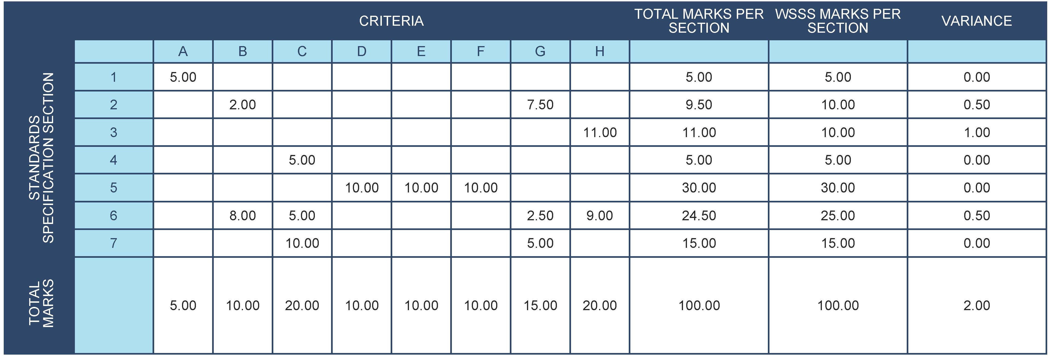
SAMPLE OF TABLE FROM CIS

assessment and marking
There is to be one marking team for each Sub Criterion, whether it is assessed and marked by judgement, measurement, or both. The same marking team must assess and mark all competitors, in all circumstances. The marking teams must be organized to ensure that there is no compatriot marking in any circumstances. (See 4.6.)

assessment and marking using judgement
Judgement uses a scale of 0-3. To apply the scale with rigour and consistency, judgement must be conducted using:
- benchmarks (criteria) for detailed guidance for each Aspect (in words, images, artefacts or separate guidance notes)
- the 0-3 scale to indicate:
  - 0: performance below industry standard
  - 1: performance meets industry standard
  - 2: performance meets and, in specific respects, exceeds industry standard
  - 3: performance wholly exceeds industry standard and is judged as excellent
Three Experts will judge each Aspect, with a fourth to coordinate the marking and acting as a judge to prevent compatriot marking.

assessment and marking using measurement
Three Experts will be used to assess each aspect. Unless otherwise stated only the maximum mark or zero will be awarded. Where they are used, the benchmarks for awarding partial marks will be clearly defined within the Aspect.

The use of measurement and judgement
Decisions regarding the selection of criteria and assessment methods will be made during the design of the competition through the Marking Scheme and Test Project.

Completion of Skill Assessment Specification
During the competition design process, the standard and assessment method chose is determined by assessment plan and test project.
The assessment terms contain but not limited to:
- The integrity and specification degree of the working process
- The integrity and specification degree of the working report
- The accuracy of the parts measurement
- The precision of the parameter adjustment for device motion and status
- If the fastening bolt is accord with the standard torque’s requirement
- The process and correction condition of the electrical installation and wiring
- The process, integration and correction condition for the parts assembly
- Troubleshoot of the defects of equipment and components
- The result of fault repair
- Teamwork proficiency
- The personal and working place protection condition
- If the operation process is accord with the safety working rules

Skill assessment procedures
The Chief Expert will divide the Experts into teams for purpose of marking and setting up marking schedules. Consideration will be given to WorldSkills experience, language and culture;
Each module/task/section will be completed on the assigned day so that progressive marking can take place;
Marking is to be entered after each section has been completed, and a programme has been developed for computer calculation after time and task data has been entered;
The Experts marking criteria and Competitor evaluation sheets, for each of the modules will be given to the Experts at the Competition.

The Test Project

General notes
Sections 0 and 4 govern the development of the Test Project. These notes are supplementary.
Whether it is a single entity, or a series of stand-alone or connected modules, the Test Project will enable the assessment of the skills in each section of the WSSS.
The purpose of the Test Project is to provide full, balanced and authentic opportunities for assessment and marking across the Standards Specification, in conjunction with the Marking Scheme. The relationship between the Test Project, Marking Scheme and Standards Specification will be a key indicator of quality, as will be its relationship with actual work performance.
The Test Project will not cover areas outside the Standards Specification, or affect the balance of marks within the Standards Specification other than in the circumstances indicated by Section 2.
The Test Project will enable knowledge and understanding to be assessed solely through their applications within practical work.
The Test Project will not assess knowledge of WorldSkills rules and regulations.
This Technical Description will note any issues that affect the Test Project’s capacity to support the full range of assessment relative to the Standards Specification. Section 2.1 refers.

Format/structure of the Test Project
The test project contains four modules:
Module A: Maintenance and control of pantograph
Module B: Installation and commissioning of passenger compartment door
Module C: Maintenance of vehicle bogie
Module D: Fault finding and repair of vehicle

Test Project design requirements

General requirements
1.All technical terms and descriptions used in the test project must conform to internationally recognized standards;
2.The design of Module A should be based on relevant standards or technical requirements. These documents will be provided to the Competitors during the competition, including:
- Standard inspection procedure, process standard of pantograph and standard torque table of fastening bolts
- Installation technical documents of pantograph control electric circuit and pneumatic circuit, which may include: schematic diagram, assembly diagram, wiring diagram, etc.
- Action setting value requirements of pantograph
3.The design of Module B should be based on relevant standards or technical requirements. These documents will be provided to the Competitors during the competition, including:
- Mechanical structure schematic diagram of passenger compartment door
- Passenger compartment door assembly process, process standards and tightening bolt standard torque table
- Passenger compartment door operation and state parameter setting requirements
- Passenger compartment door control circuit schematic, assembly or wiring diagram
- Systematic functional test indicators for passenger compartment doors
4.The design of Module C should be based on relevant standards or technical requirements. These documents will be provided to the Competitors during the competition, including:
- Standard inspection procedures and process standards for bogies
- Mechanical structure schematic diagram of bogie
- Disassembly and installation process of bogie components and standard torque table of fastening bolts
- Parameter setting requirements for bogie components
5.The design of module D should be based on relevant standards or technical requirements. These documents will be provided to the Competitors during the competition, including:
- Vehicle standard inspection process and process standards
- Vehicle circuit diagram
- Vehicle electrical components layout
- Vehicle operation, maintenance manual

Maintenance and control of pantograph
This module should mainly include the inspection and maintenance of vehicle pantograph mechanical parts, installation of control electric circuit and pneumatic circuit, function commissioning, etc., it should comprehensively examine the Competitors' safe operation, standard inspection, defect judgment, maintenance and repair, drawing reading, installation skills, pantograph commissioning and other operation skills.
The main tasks and requirements are as follows:
1. Inspection and maintenance of pantograph, operation requirements:
- Inspect and record pantograph components according to standard procedures
- Check that all fastening bolts, connecting parts and electrical connections are tight
- Maintain or repair pantograph defects according to process standards, and record them
2.Installation and wiring of the control circuit, operation requirements:
- Complete the installation and wiring of the control circuit according to the relevant technical documents of the pantograph control circuit
- Complete electrical connection between pantograph and Ground Test Bench
- The installation and wiring of the control circuit must meet the requirements of standard electrical processes
3. Installation of the control pneumatic circuit, operation requirements:
- Complete installation of the control pneumatic circuit, according to the relevant technical documents of the pantograph pneumatic circuit
- The installation of the control pneumatic circuit must meet the construction technical requirements
4. Use the Ground Test Bench to perform pantograph function test, operation requirements:
- Air tightness test of pantograph air pipe, no leakage
- The pantograph's lifting and lowering function test meets the requirements of technical documents
- Test of pantograph's control circuit, and the control logic meets the design requirements of the schematic
- Record the test process correctly
5. Adjustment and setting of pantograph action parameters, operation requirements:
- Adjust the process of the pantograph's lifting and lowering, and meet the requirements of technical documents
- Adjust the pantograph lifting time according to the setting value
- Adjust the pantograph lowering time according to the setting value
- Adjust the pantograph static contact force according to the setting value
- Adjust the balance state of collector head
During the above operation process, the competitor’s personal protection and device protection should be in accordance with the safety requirements.

Installation and commissioning of passenger compartment doors
This module should mainly include the assembly and installation of the control mechanism of the passenger compartment door, the state adjustment of the passenger compartment door, functional commissioning, and systemic testing, etc. It should comprehensively examine the Competitors' safe operation, fault component identification, drawing reading, assembly process, door commissioning and adjustment and other operation skills.
The main tasks and requirements are as follows:
1. Assembly of parts of passenger compartment door control mechanism, the operation requirements:
- Check the components of the passenger compartment door control mechanism to ensure that the components meet the requirements for use
- Identify faulty parts and replace if necessary
- Assemble the control mechanism of the passenger compartment door according to the process standard
2. Control mechanism installation and passenger compartment door adjustment, the operation requirements:
- Install the control mechanism to the carbody according to the process standard
- Install door leaf to the control mechanism according to process standard
- Adjust parameters of passenger compartment door according to technical standards
- Complete the electrical connection between the passenger compartment door and the Ground Test Bench
3. Use the Ground Test Bench for testing, the operation requirements:
- Door opening and closing action test
- Door opening and closing time test
- Door closing force test
- Obstacle detection test
- The electrical control logic test of the door, and meet the requirements of the schematic design
- Door alarm test
- Door isolation test
- Door unlock test
- Systematic testing of passenger compartment door in combination with the actual operating environment of the train
- Test process record
During the above operation process, the Competitor’s personal protection and device protection should be in accordance with the safety requirements.

Maintenance of vehicle bogie
The module should mainly include inspection, measurement, adjustment, maintenance, and component replacement of bogies, etc. It should comprehensively examine the Competitors' safety operations, defect identification, component disassembly and installation processes, component maintenance, mechanical part measurement, parameter adjustment and other operation skills.
The main tasks and requirements are as follows:
1.Bogie appearance inspection
- Visually inspect bogie according to the standards and record the inspection contents
2.Measurement and parameter adjustment of bogie components, which may include:
- Measurement of wheelset inner distance, tread and rim of bogie
- Lateral stop rubber gap measurement
- Brake shoe or pad thickness measurement
- Ground carbon brush thickness measurement
- Measurement and adjustment of the gap between primary spring and axle box
- Measurement and adjustment of the distance between the top surface of the air spring and the top of rail
- Measurement and adjustment of the installation position of the flange lubrication device
3. Replacement (disassembly, assembly) of bogie components, which may include:
- Lateral damper replacement
- Vertical damper replacement
- Brake replacement
- Disassembly and replacement of axle box device
- Anti-rolling torque rod replacement
- Height adjustment valve replacement
During the above operation process, the Competitor’s personal protection and device protection should be in accordance with the safety requirements.

Fault finding and repair of vehicle
This module should mainly include vehicle inspection, measurement, testing, and electrical fault repair, etc. It should comprehensively examine the Competitors' safe operation, vehicle inspection, electrical fault diagnosis, troubleshooting skills and other operation skills in the vehicle environment.
The main tasks and requirements are as follows:
1.Mechanical fault finding and recording:
The troubleshooting of vehicle mechanical parts mainly includes two parts: body parts and interior parts. The body parts include the equipment of the roof, body and underframe; the interior parts include the equipment in the driver's cab, passenger compartment, gangway, and equipment cabinets. The Competitors are required to inspect all parts and find out the faulty parts through visual inspection, measurement, and trial operation, and make records at the same time.
2. Electrical fault finding, recording and repair:
The Competitors are required to complete the troubleshooting of control circuits such as train activation, driver's cab occupation, vehicle assistance, emergency brake, pantograph lifting and lowering, door opening and closing, parking brake, traction, braking, air conditioning. In addition, record and repair the faults found.
At the same time, the Competitors are required to complete the diagnosis of network-related faults by checking the network status displayed on the train display screen, analyzing the network topology, downloading and analyzing the network data and record them.
The overall recommended time for the above modules is 20 hours.
Module | TIME
Module A：Maintenance and control of pantograph | 6 hours
Module B：Installation and commissioning of passenger compartment door | 8 hours
Module C：Maintenance of vehicle bogie | 4 hours
Module D：Fault finding and repair of vehicle | 2 hours
Total | 20 hours

Test Project development
The Test Project MUST be submitted using the templates provided by WorldSkills International (www.worldskills.org/expertcentre). Use the Word template for text documents and DWG template for drawings.

Who develops the Test Project or modules
The Test Project modules are designed by an industry partner team to reflect current and upcoming technologies.

How and where is the Test Project or modules developed
The Test Project/modules are developed by the Independent Designer in consultation with the Skill Competition Manager (SCM)

When is the Test Project developed
Option one:
The circulated versions of each module will be ready and sent to the WorldSkills Director of Skills Competitions to be made available via the WorldSkills website three (3) months before the competition. The Test Project modules will be changed a minimum of 30% by the module groups prior to the competition within the Discussion Forum. Surprise modules may be developed with an industry partner – these will be kept confidential until the Competition.
Option two:
The circulated versions of each module will be ready and sent to the WorldSkills Director of Skills Competitions to be made available via the WorldSkills website three (3) months before the competition. The Test Project modules will be changed a minimum of 30% by the Skill Competition Manager and/or an industry partner.
The Test Project is developed according to the following timeline:
TIME | ACTIVITY
Seven (7) months prior to the Competition | Experts are divided into Test Project Module Groups by the CE and DCE. Each group of Experts will develop a specific module on a closed forum lead by their Module Expert.
Five (5) months prior to the Competition | First drafts of each module will be posted on the forum in the respective private Module Group forum area.
Three (3) months prior to the Competition | Circulated Test Project modules are sent to the WorldSkills Director of Skills Competitions to be distributed via the WorldSkills International website.
Three (3) months prior to the  Competition | Option one:  After the Circulated Project has been sent to the WorldSkills Director of Skills Competitions the Module Groups in the forum will start work on the minimum 30% change to their Test Project modules within the respective private Module Group forum area.  Option two:  After the Circulated Project has been sent to the WorldSkills Director of Skills Competitions will provide the Pre-Competition Files and an example past Pre/Final Competition Documentation to an industry partner. The PreCompetition will then be changed by a minimum 30%. This change will be presented to all Experts at the Competition.  The 30% change will be kept confidential and will not be disclosed to any other Expert outside of the Module Group or to any Competitor.
At the  Competition | Option one: The Module Lead Expert for each Expert Module Group presents their Test Project module(s) with the minimum 30% change to all Experts. All Test Project files will be finalized.  Option two: The independent agency presents their Test Project module(s) with the minimum 30% change to all Experts. All Test Project files will be finalized.
At the  Competition | Interpreters will have the opportunity to translate all Test Project files where required.

Test Project validation
The final Test Project modules will be validated by the respective module group prior to the Competition. The Skill Competition Manager will provide assistance to Module Groups for the validation of projects. Module groups will ensure that:
- The module can be completed in the specified time;
- The module can be completed with the equipment, tools and materials provided;
- The marking schemes are appropriately developed;
- The Test Project meets the WorldSkills Standards Specification.

Test Project selection
The Test Project is selected by the Industry Partner

Test Project circulation
The Test Project is circulated via the website as follows:
Three months before the current Competition.

Test Project coordination (preparation for Competition)
Coordination of the Test Project will be undertaken by the Skill Competition Manager.
The Skill Competition Manager is responsible for ensuring the following:
- There are no installation requirements that cannot be completed;
- The tasks can be completed in the prescribed time;
- Proper function is achievable;
- The material/equipment list is accurate;
- Competitor instructions are kept to a minimum of text, and that they do not exceed the available space permitted on the approved instruction sheet for any one module;
- The Test Project is complete in all aspects;
Industry carries out a quality assurance check on all Test Projects

Test Project change at the Competition
Refer When is the Test Project developed5.4.3 When is the Test Project developed.

Material or manufacturer specifications
Specific material and/or manufacturer specifications required to allow the Competitor to complete the Test Project will be supplied by the Competition Organizer and are available from www.worldskills.org/infrastructure located in the Expert Centre.
If specific material or manufacturer specifications are required to allow the Competitor to complete the Test Project, it will be provided along with the Test Project, the Workshop Manager must arrange a demonstration on site during Familiarization Day.

Skill management and communication

Discussion Forum
Prior to the Competition, all discussion, communication, collaboration, and decision making regarding the skill competition must take place on the skill specific Discussion Forum (http://forums.worldskills.org). Skill related decisions and communication are only valid if they take place on the forum. The Chief Expert (or an Expert nominated by the Chief Expert) will be the moderator for this Forum. Refer to Competition Rules for the timeline of communication and competition development requirements.

Competitor information
All information for registered Competitors is available from the Competitor Centre (www.worldskills.org/competitorcentre).
This information includes:
- Competition Rules
- Technical Descriptions
- Mark Summary Form (where applicable)
- Test Projects (where applicable)
- Infrastructure List
- WorldSkills Health, Safety, and Environment Policy and Regulations
- Other Competition-related information

Test Projects [and Marking Schemes]
Circulated Test Projects will be available from www.worldskills.org/testprojects and the Competitor Centre (www.worldskills.org/competitorcentre).

Day-to-day management
The day-to-day management of the skill during the Competition is defined in the Skill Management Plan that is created by the Skill Management Team led by the Skill Competition Manager. The Skill Management Team comprises the Skill Competition Manager, Chief Expert, and Deputy Chief Expert. The Skill Management Plan is progressively developed in the six months prior to the Competition and finalized at the Competition by agreement of the Experts. The Skill Management Plan can be viewed in the Expert Centre (www.worldskills.org/expertcentre).

Skill-specific safety requirements
Refer to WorldSkills Health, Safety, and Environment Policy and Regulations for Host country or region regulations.
The following skill-specific safety requirements are to be adhered to by the Competitors and Experts.
- All Competitors must wear PPE at all times in the workshop area;
- All Competitors must use safety glasses when using any hand, power, or machine tools or equipment likely to cause or create chips or fragments that may injure the eyes;
- All Competitors must confirm that the working environment (place) is safe and their operation will not cause harm to rest of the team;
- Competitors must keep their work area clear of obstacles and their floor area clear of any material, equipment, or items likely to cause someone to trip, slip, or fall;
- Experts will use the appropriate personal protective equipment when inspecting, checking, or working with a Competitor's project.

Materials and equipment

Infrastructure List
The Infrastructure List details all equipment, materials and facilities provided by the Competition Organizer.
The Infrastructure List is available at www.worldskills.org/infrastructure.
The Infrastructure List specifies the items and quantities requested by the Experts for the next Competition. The Competition Organizer will progressively update the Infrastructure List specifying the actual quantity, type, brand, and model of the items. Items supplied by the Competition Organizer are shown in a separate column.
At each Competition, the Experts must review and update the Infrastructure List in preparation for the next Competition. Experts must advise the Director of Skills Competitions of any increases in space and/or equipment.
At each Competition, the Technical Observer must audit the Infrastructure List that was used at that Competition.
The Infrastructure List does not include items that Competitors and/or Experts are required to bring and items that Competitors are not allowed to bring – they are specified below.

competitors toolbox
Toolboxes are NOT allowed to be brought to the competition as all necessary tools will be supplied.

Materials, equipment, and tools supplied by Competitors in their toolbox
Competitors are not required to bring any tools.

Materials, equipment, and tools supplied by Experts
Not applicable.

Materials and equipment prohibited in the skill area
Materials and tools not in accordance to the Host Country Health, Safety, and Environment regulations are prohibited.
The following items are not allowed in the workshop: mobile telephones, any electronic communication transmitters and receivers, audial and visual recording equipment, and any personal tools;
Competitors may not supply components as spare parts.

Proposed workshop and workstation layouts
Workshop layouts from previous competitions are available at www.worldskills.org/sitelayout.
This competition is carried out by adopting rotation mode, and the competition positions are placed to meet the requirement for 8 teams’ competition. The ultimate site layout should be adjusted or expanded according to the actual participated team number.
Example workshop layout:
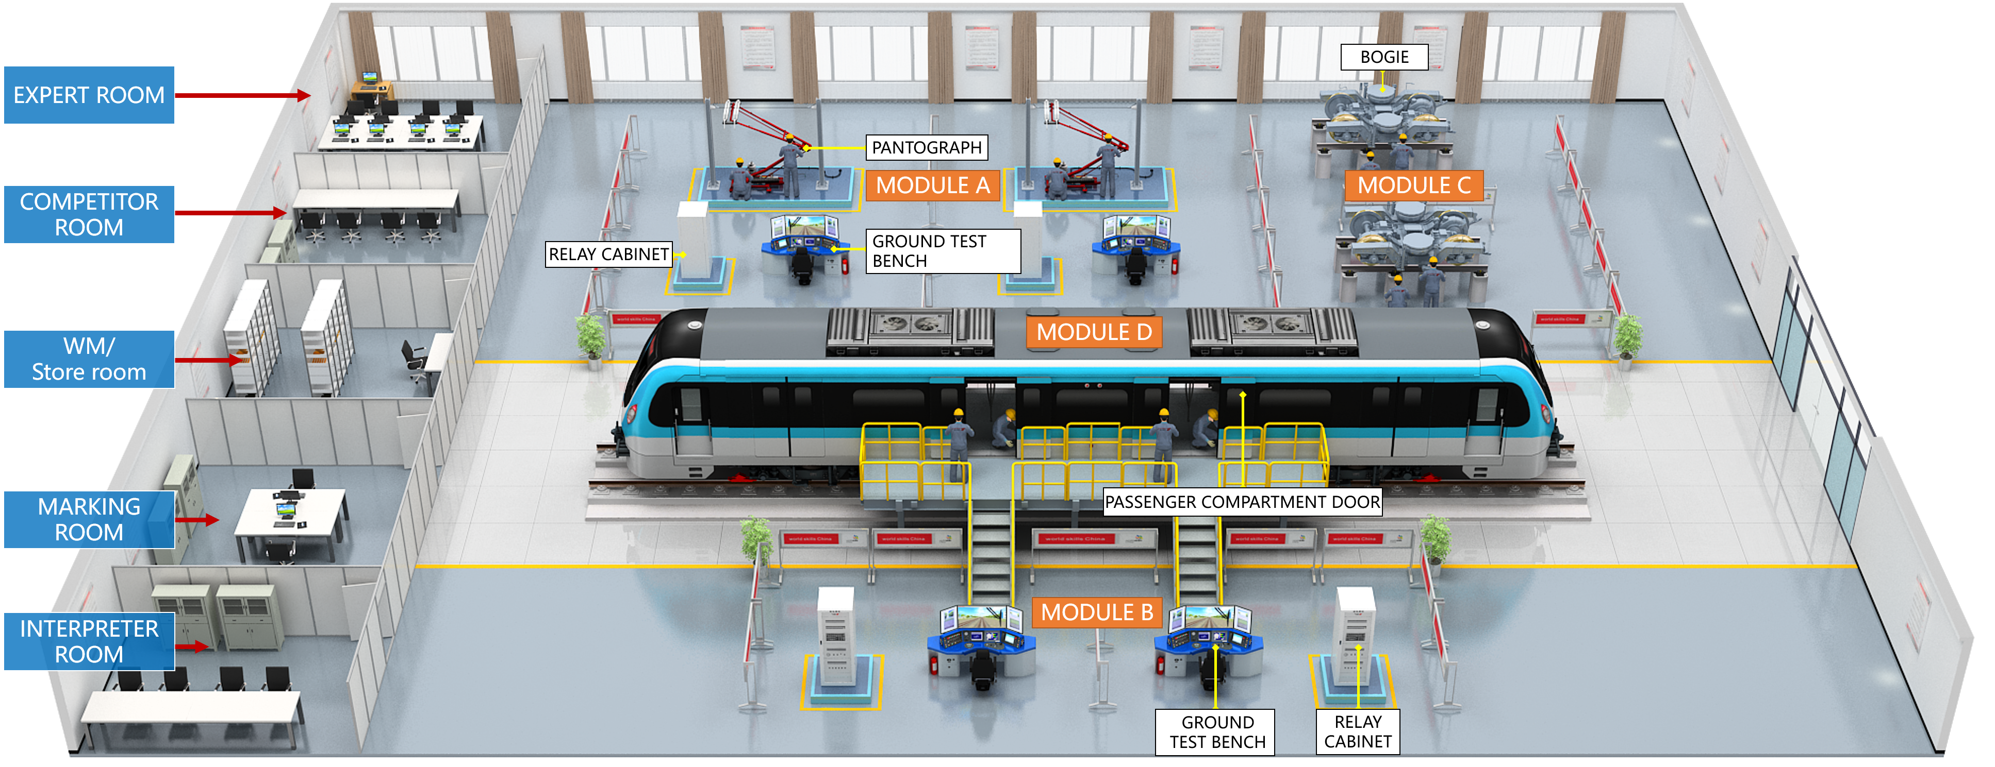
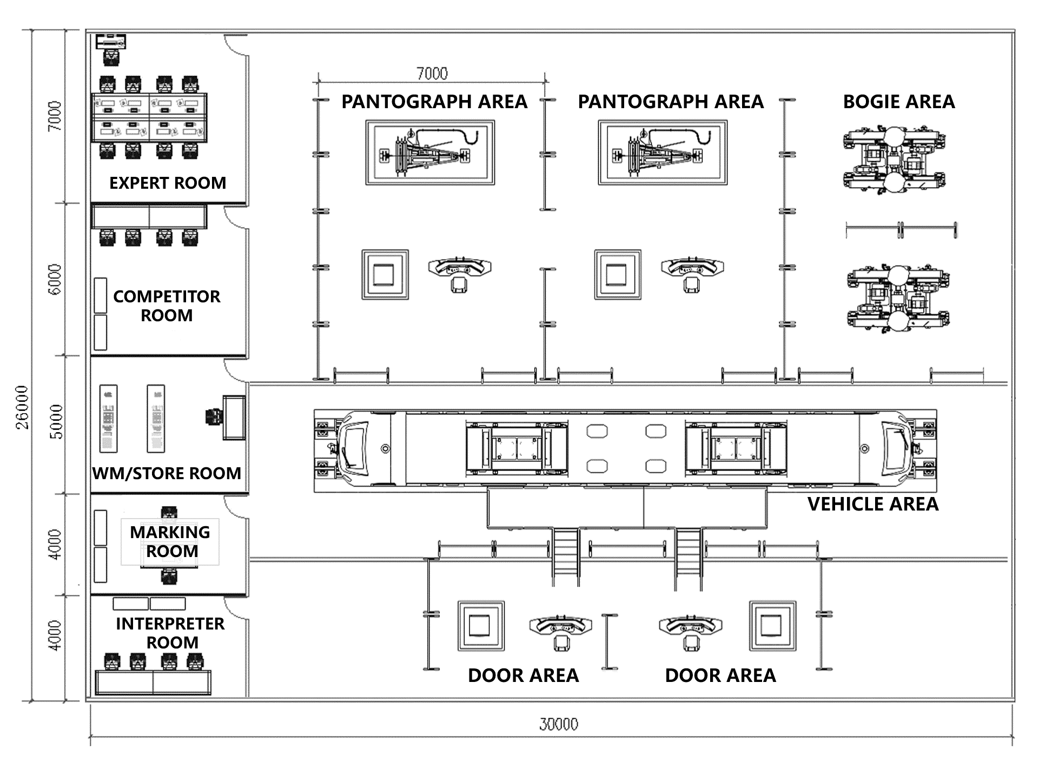

Skill-specific Rules
Skill-specific rules cannot contradict or take priority over the Competition Rules. They do provide specific details and clarity in areas that may vary from skill competition to skill competition. This includes but is not limited to personal IT equipment, data storage devices, internet access, procedures and work flow, and documentation management and distribution.
TOPIC/TASK | SKILL-SPECIFIC RULE
Use of technology – USB, memory sticks | - Competitors, Experts, and Interpreters are not allowed to bring memory sticks into the workshop.
Use of technology – personal laptops, tablets and mobile phones | - Competitors, Experts, and Interpreters are not allowed to bring personal laptops, tablets or mobile phones into the workshop.
Use of technology – personal photo and video taking devices | - Competitors, Experts, and Interpreters are only allowed to use personal photo and video taking devices in the workshop at the conclusion of the competition.  - Experts are allowed to use a dedicated camera and memory device as required for the marking process. These must be approved by the Chief Expert.
Aids, etc. | - Competitors are not allowed to bring aids to the Competition that may give them an unfair advantage.
Drawings, recording information | - Competitors are not allowed to bring any prepared drawings or documented information to the Competition.
Health, Safety, and Environment | - Refer to the WorldSkills Health, Safety, and Environment policy and guidelines document.

visitor and media engagemenT
The following list provides examples of how this skill competition may be more attractive for the media and visitors:
- Equipped with rail transit train simulation driving experience system to attract public participation for driving and experience;
- Equipped with VR, AR, MR virtual maintenance system enables public and young visitor to participate the skill;
- Invite media to engage for ensuring the coverage and persistence;
- Will strengthen the display of the competition process by 5G live network broadcast, get the competition scene on the Internet;
- Equipped with screens to play the worker’s actual working site, the devices and tools used during work;
- Test project descriptions will be simplified for visitors and make them clear, visible and understandable by visitors;
- Provide competitors profile, including their age, career, working experience, education background, etc.;
- Daily reporting of competition status - All results will be displayed in the Competition area as per previous Competitions. This will be of the progressive marking for all sections of the Competition and will display the current total aggregate results per country/region;
- Invite international rail transit organizations and companies to discuss with Worldskills experts and exchange ideas for improving future competitions;
- Invite as possible, sponsor non_members of WorldSkills having rail transit systems to visit and experience the skill competition and promotion in order to attract more non_members of WorldSkills to participate in future
.
.

Sustainability
This skill competition will focus on the sustainable practices below:
- The main device is provided by sponsor or partner, necessary site and device management cost would be provided. Once the competition finishes, the Test Project device could be re-installed in colleges or company training institutes for students and employee skill training purpose;
- During designing of Test Projects and liaising with the current Workshop Manager, the uses of “green” materials are to be considered. Materials that meet the following requirements are to be used as far as possible:
      - Halogen free;
      - Recyclable;
      - Free from toxic substances.
- Materials that can be reused, are to be offered to local schools to be used in education for training purpose. Materials that cannot be reused are to be sorted as per Host Country regulations or, if meeting higher requirements, WorldSkills regulations;
- Competitors must take special consideration when designing and packing their tool box for the competition. They must ensure they only pack the minimum number of tools needed to complete the competition;
- Make sure the devices in infrastructure list will all be used;
- The industry partner designing the Test Project must carefully consider sustainability as a key issue;
- All paperwork prepared at the previous competition must be electronically copied by the new Chief and Deputy Chief Expert.

References for industry consultation
WorldSkills is committed to ensuring that the WorldSkills Standards Specifications fully reflect the dynamism of internationally recognized best practice in industry and business. To do this WorldSkills approaches a number of organizations across the world that can offer feedback on the draft Description of the Associated Role and WorldSkills Standards Specification on a two-yearly cycle.
In parallel to this, WSI consults three international occupational classifications and databases:
- ISCO-08: (http://www.ilo.org/public/english/bureau/stat/isco/isco08/)
- ESCO: (https://ec.europa.eu/esco/portal/home )
- O*NET OnLine (www.onetonline.org/)
Your competition appears most closely to relate to Rail Car Repairers:
https://www.onetonline.org/link/summary/49-3043.00
and/or Rolling Stock Electrician:
https://ec.europa.eu/esco/lod//occupation/fd86ebe1-bad4-4486-9b76-01a48030e49a
Adjacent occupations can also be explored through this link.
The following table indicates which organizations were approached and provided valuable feedback for the Description of the Associated Role and WorldSkills Standards Specification in place for WorldSkills Shanghai 2021.
ORGANIZATION | CONTACT NAME
Chinese Academy of Engineering,  CRRC Corporation Limited (China) | Ding Rongjun, Academician ,Scientist
International Union of Railways (UIC),  China Academy of Railway Sciences Corporation Limited (CARS) | Zhao Hongwei, UIC Coordinator, CARS Lead Researcher  Zhang Bo, UIC Coordinator, CARS Researcher
R&D Center of Transport Industry of Technologies and Equipment of Urban Rail Operation Safety Management | Zhang Anquan, Director

